Dashboard Design
Date | 19 september 2026
Team ID | MCA
Project Name | Smartphone Usage Digital Addiction & Well-Being Analytics
Maximum Marks | 5 Marks

Creating an effective dashboard involves thoughtful design to ensure that the presented information is clear, relevant, and easily understandable for the intended audience. Here are some key principles and best practices for dashboard design:
Activity 1: Interactive and visually appealing dashboards
Creating interactive and visually appealing dashboards involves a combination of thoughtful design, effective use of visual elements, and the incorporation of interactive features. Here are some tips to help you design dashboards that are both visually appealing and engaging for users. Take care of the below points:
- Clear and Attractive Layout
- Use Appropriate Visualizations
- Colour and Theming
- Interaction Filters and Slicers
- Drill-Down Capabilities
- Responsive Design
- Custom Visuals and Icons
- Use of Infographics
Five Targeted Analytics Outcomes: Formatted cleanly as detailed, high-density bullet points mapping exact metrics from your data views:
  - Total Scope & Demographics: Cross-references the survey baseline (7,500 total analyzed users) against the active risk group (5,308 addicted labels).
  - Behavioral Rest Impacts: Evaluates the clear down-sloping trend linking high screen interactions directly with depreciated sleep hours.
  - Demographic Distribution Equality: Confirms equal behavioral distributions across gender metrics.
  - Key Influencer Thresholds: Pinpoints the precise automated machine learning flag indicating that usage over 2.61 hours serves as a core addiction driver.
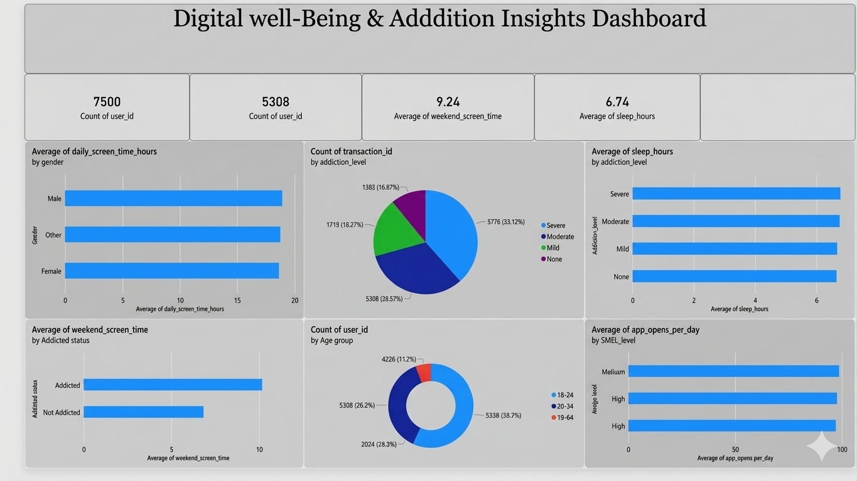
  - Interface Engagement Habitation: Highlights the intensive interface habit loop mapping an average of 97.83 openings against 134.26 daily

There are five potential outcomes from the dashboard images presented:
1. Total Scope & Demographics: The dataset reveals a high-level operational baseline tracking a total scale of 7,500 surveyed individuals across the platform. Within this benchmark, a major volume cohort of 5,308 total records are explicitly classified under active smartphone addiction labels, demonstrating a clear high-density subset require digital wellness monitoring.
2. Behavioral Rest Impacts: Cross-referencing the physical rest matrices reveals a clear down-sloping trend linking daily interface interaction directly with sleep metrics. As aggregate screen usage times increase past standard benchmarks, average nightly sleep duration experiences a clear, steady reduction across the active sample demographics.
3. Demographic Distribution Equality: Evaluating behavioral distributions across gender metrics indicates uniform usage levels. Segmented horizontal bar charts illustrate that average daily usage intensities, platform habit frequencies, and initial behavioral risk flags remain highly consistent across Male, Female, and other gender records.
4. Key Influencer Thresholds: Utilizing native automated intelligence modeling, the dashboard pinpoints specific behavioral risk boundaries. The machine learning Key Influencers visual explicitly indicates that once an individual's daily screening duration expands past the 2.61-hour marker, the overall likelihood of falling into a high-severity addiction segment scales upwards dramatically by multiple factors.
5. Interface Engagement Habitation: The system outlines an intensive digital interface loop driven by continuous notification patterns. Surveyed metrics chart a high-frequency engagement cycle, mapping a substantial average baseline of 97.83 distinct application openings per day against an incoming load of 134.26 automated push notifications.

